**SRI VENKATESHWARA GOVERNMENT POLYTECHNIC,TIRUPATI -517501**



**DEPARTMENT OF COMPUTER ENGINEERING**

**DOCUMENTATION OF SAMPLE TRY-OUT**

**(AP ECET MOCK TEST WEBSITE)**

**CERTIFICATE**

**INDEX OF SAMPLE TRY-OUT**

**CHAPTER NO DESCRIPTION PAGE NO**

**Abstract i**

1 Introduction

2 Project Description

3 Computational Environment

3.1 Software requirements

3.2 Hardware requirements

3.3 Operating environment

3.4 External Interface Requirements

3.5 Non-Functional Requirements

3.6 Software Features

4 Feasibility Study

4.1 Technical Feasibility

4.2 Operating Feasibilty

4.3 Economical Feasibility

5 System Analysis

5.1 Existing System

5.1.1 Drawbacks in Existing System

5.2 Proposed System

5.2.1 Advantages of proposed system

6 System Design

6.1 Data flow Diagrams

6.2 UML Diagrams

7 System Implementation

8 Testing

8.1 Unit Testing

8.2 Integration Testing

8.3 System Testing

8.4 Acceptance Testing

9 Sample Course Code

10 Screen Layouts

11 Conclusion and Future Enhanceme

ABSTRACT

### INTRODUCTION

### 

### 4. Feasibility study

#### 4.1. Technical Feasibility

Building online ECET MOC test is technically feasible. The hardware and software needed are all available, it not difficult to get them. Brief I can say the necessary resources needed for the development and maintenance of the system are available. Evaluated the availability of resources such as skilled personnel, equipment, materials, and financial resources to undertake and sustain the project. I am going to use html, java script, ajax, jquerry ,PHP and sql database.

#### 4.2. Operationally Feasibility

The project I am developing is operationally feasible as there is no need for users to have good knowledge in computer before using it. Evaluated the practicality, usability, and acceptance of the project by the users . I considered the user level of acceptance, willingness to adopt the new system, and potential resistance to change. The user can learn and use the system with easiness; he just needs to read the manual or tutorial from the developers.

#### 4.3. Economic Feasibility

Besides being technically feasible, developing this system is economically feasible as well. The development of the system does not require the developers to spend a lot of money. Assessed the costs involved in developing, implementing, and operating the project, including hardware, software, infrastructure, training, maintenance, and ongoing operational expenses The tools I will be using to develop the system are not expensive and the software’s are open source. All I need is time. Even the maintenance of the system will not be expensive. The system is indeed economically feasible.

**6 System Designs**

**6.1 Data Flow Diagrams**

DATA BASE

LOGIN PAGE

SIGN PAGE

LOGIN

SIGN IN

TEST

CONTACT

HOME

USER

FEED BACK

Registration Verification

TEST

Ready to test

Question Retrieving

from database

ECE TEST

EEE TEST

CSE TEST

answer evaluation

from database

RESULT

**6.2 UML Diagram**

**Registered verification**

**User**

Data Base

**user**

**Registration**

**New user**

**10 Sample Source Code :**

**10.1 Homepage Source code**

<!DOCTYPE html>

<html lang="en">

<head>

<meta charset="UTF-8">

<meta name="viewport" content="width=device-width, initial-scale=1.0">

<title>Mock Test Website</title>

<link rel="stylesheet" href="homepage.css">

</head>

<body>

<div class="header">

<div class="header_nav">

<img src="logo.jpeg" alt="">

<p>SAMPLE TRY-OUT</p>

</div>

<ul class="nav">

<li ><a href="HOMEPAGE.HTML">Home</a></li>

<li ><a href="sign_in_student.html">Tests</a></li>

<li ><a href="contact.html">Contact</a></li>

<li ><a href="login.html">login</a></li>

<li ><a href="sign_in_student.html">signup</a></li>

</ul></div>

<div class="content">

<h1>Welcome to ECET Mock Test Website</h1>

<p>Mock tests are arranged to give students a feel of the real exam. For most of the students about to take a major exam for the first time in their lives, mock tests provide a trial run. Being placed in the same situation and feeling the same amount of pressure before the actual competative exam will inculcate some self-analytical capacity and confidence in the student. Infact Mock Test helps in reducing pre-exam nervousness, as the candidate has already appeared for a version of the exam before, on the final day he will be more relaxed.</p>

<h2>"PRACTICE MAKES MAN PERFECT"</h2>

<button class="header__btn">

<a href="sign_in_student.html">LET'S PRACTICE</a>

</button> </div>

<section class="features">

<div class="container">

<h2 class="features__title">Features</h2>

<div class="features__grid">

<div class="features__item">

<img src="image2.png" alt="" id="flogo">

<h3 class="features__item-title">Expertly Written Questions</h3>

<p class="features__item-text">Our team of experts writes every question with care and precision to provide the most accurate and reliable results.</p>

</div>

<div class="features__item">

<img src="image1.png" alt="" id="flogo">

<h3 class="features__item-title">Realistic Testing Environment</h3>

<p class="features__item-text">Our timed tests simulate the real testing environment to help you feel comfortable and confident on test day.</p>

</div>

<div class="features__item">

<img src="image3.png" alt="" id="flogo">

<h3 class="features__item-title">Track Your Progress</h3>

<p class="features__item-text">Our detailed reports and analytics allow you to track your progress and identify areas where you need to improve.</p>

</div>

</div>

</div>

</section>

<section class="cta">

<div class="container">

<h2 class="cta__title">Ready to Get Started?</h2>

<p class="cta__subtitle">Sign up for free and start testing today!</p>

<a href="sign_in_student.html" class="cta__btn">Sign Up Now</a>

</div>

</section><footer class="footer">

<div class="container">

<p class="footer__text">&copy; 2023 Mock Test Website. All rights reserved.</p> </div>

</footer>

</body>

</html>

**10.2 Sign in page Source Code**

<!DOCTYPE html>

<html lang="en">

<head>

<title>Sign Up</title>

<link rel="stylesheet" href="style.css" />

<link

href="https://fonts.googleapis.com/css2?family=Roboto:wght@300&display=swap"

rel="stylesheet"/>

<style>

.lin{

width:80px;

height: 40px;

background-color:white;

box-shadow:10px white;

border-radius: 5px;

margin-left: 45%;

align:center;

}

</style>

<script src="https://ajax.googleapis.com/ajax/libs/jquery/3.6.0/jquery.min.js"></script>

<script>

$(document).ready(function()

{

$(".mn").click(function(){

$(".mn").css("border-color","black");

})

$(".mn1").click(function(){

$(".mn1").css("border-color","black");

})

$(".mn2").click(function(){

$(".mn2").css("border-color","black");

})

$(".mn3").click(function(){

$(".mn3").css("border-color","black");

})

$(".mn4").click(function(){

$(".mn4").css("border-color","black");

})

$(".mn5").click(function(){

$(".mn5").css("border-color","black");

})

$(".mn6").click(function(){

$(".mn6").css("border-color","black");

})

});

</script>

</head>

<body>

<div class="signup-box">

<h1>Sign Up</h1>

<h4>It's free and only takes a minute</h4>

<form name="myform" action="insert_student.php" method="post" >

<label>Name</label>

<input type="text" class="mn"placeholder="Enter Student name" name="name" required><br>

<label>student ID</label>

<input type="username" class="mn1" placeholder=" Enter your Diploma HallTicket Number" name="student_id" required>

<label>College Name</label>

<input type="text" class="mn2"placeholder="Enter your college name" name="college_name" required>

<label>Course</label>

<input type="text" class="mn3" placeholder=" Enter your department name" name="course" required>

<label>Email</label>

<input type="e-mail" class="mn4"placeholder="Enter your e-mail ID" name="e-mail" required>

<label>Username</label>

<input type="text" class="mn5"placeholder="Enter Username" name="username" required>

<label>Password</label>

<input type="password" class="mn6" placeholder="Enter 8 digit password" name="password" required><br><br><br>

<input type="submit" value="SUBMIT" />

</form><br><br><br>

<p class="aa">

By clicking the submit button,you agree to our <br />

<a href="terms_conditions.html" class="a">Terms and Condition</a>and<a href="terms_conditions.html" class="a">Privacy Policy</a>

</a></p>

<table><tr>

<td> <button class="lin"><a href="HOMEPAGE.HTML">HOME</a></button></td><td>&nbsp;&nbsp;&nbsp;&nbsp;&nbsp;&nbsp;&nbsp;&nbsp;

&nbsp;&nbsp;&nbsp;&nbsp;&nbsp;&nbsp;&nbsp;&nbsp;&nbsp;&nbsp;&nbsp;&nbsp;&nbsp;&nbsp;&nbsp;&nbsp;&nbsp;&nbsp;&nbsp;&nbsp;&nbsp;&nbsp;&nbsp;

&nbsp;&nbsp;&nbsp;&nbsp;&nbsp;&nbsp;&nbsp;&nbsp;&nbsp;&nbsp;&nbsp;&nbsp;&nbsp;&nbsp;&nbsp;</td>

<td><button class="lin"><a href="terms_conditions.html">NEXT</a></button></td></tr>

</table> </div>

<p class="para-2">

Already have an account? <a href="login.html">Login here</a>

<!--

</p class="para-3">

</body>

**</**html**>**

**10.3 Log in Page Source Code**

<!DOCTYPE html>

<html lang="en">

<head>

<title>Login </title>

<link rel="stylesheet" href="style.css" />

<link

href="https://fonts.googleapis.com/css2?family=Roboto:wght@300&display=swap"

rel="stylesheet />

<script src="https://ajax.googleapis.com/ajax/libs/jquery/3.6.0/jquery.min.js"></script>

<script>

$(document).ready(function()

{

$("#mn").click(function(){

$("#mn").css("border-color","black");

})

$("#mn1").click(function(){

$("#mn1").css("border-color","black");

})

$("#mn2").click(function(){

$("#mn2").css("border-color","black");

})

});

</script> </head>

<body>

<div class="login-box">

<h1>Login</h1>

<form action="login_action1.php" method="POST">

<label>STUDENT ID</label>

<input type="username" id="mn2" placeholder="Enter Diploma Hall Ticket Number" name="id" required>

<label>Email</label>

<input type="email" id="mn" placeholder="Enter Mail Id Ex:abc12@gmail.com " name="username" required>

<label>Password</label>

<input type="password" id="mn1" placeholder=" Enter 8 digit code " name="password" required><br><br>

<input type="submit" value="LOGIN" style="background-color:green;color:white;" />

</form>

<p> By clicking the submit button,you agree to our <br /><a href="terms_conditions.html">Terms and Condition</a> and <a href="terms_conditions.html">Privacy Policy</a>

</p>

</div>

<p class="para-2"> Not have an account? <a href="sign_in_student.html">Sign Up Here</a>

</p>

</body></html>

**11 Screen Layouts**

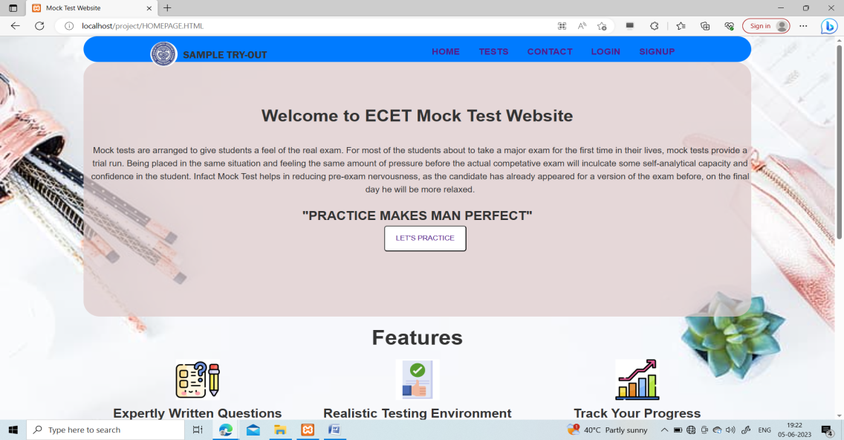

Homepage 1

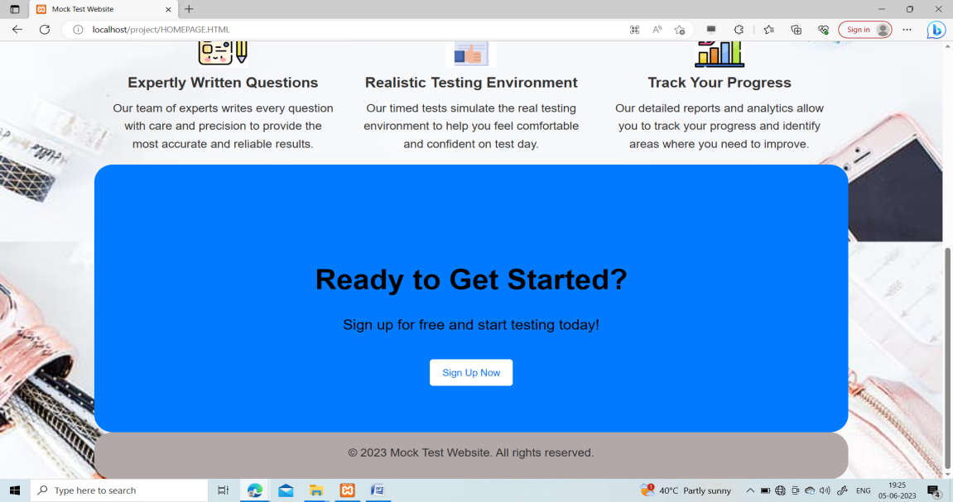

Homepage 1.1

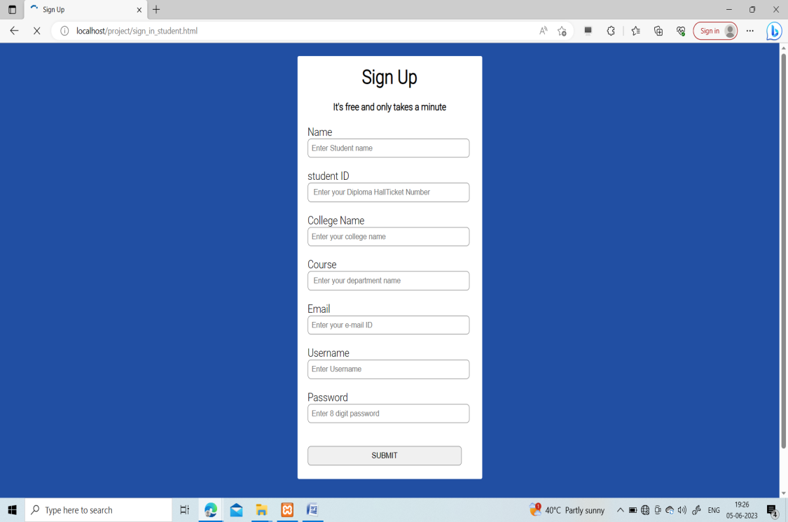

Sign in page

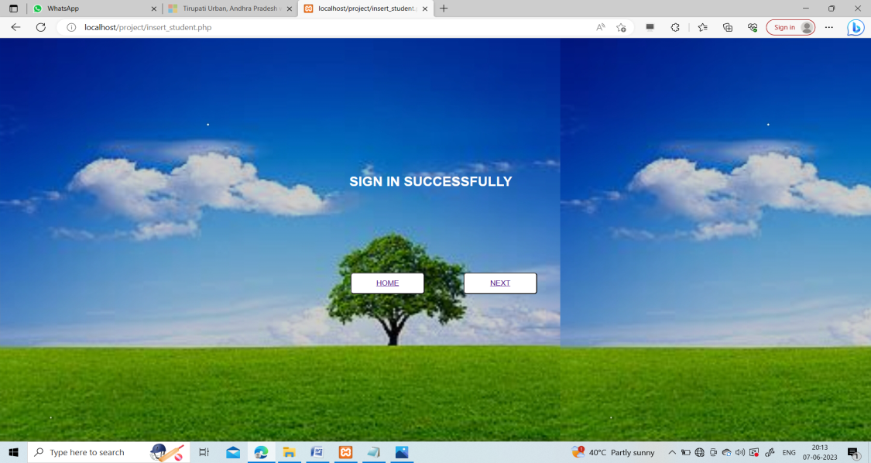

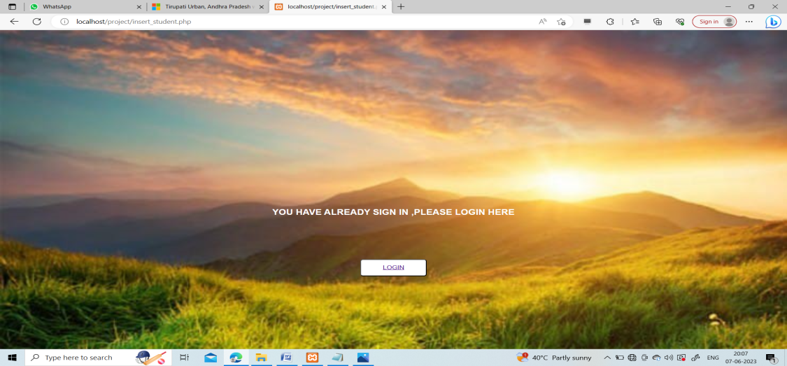

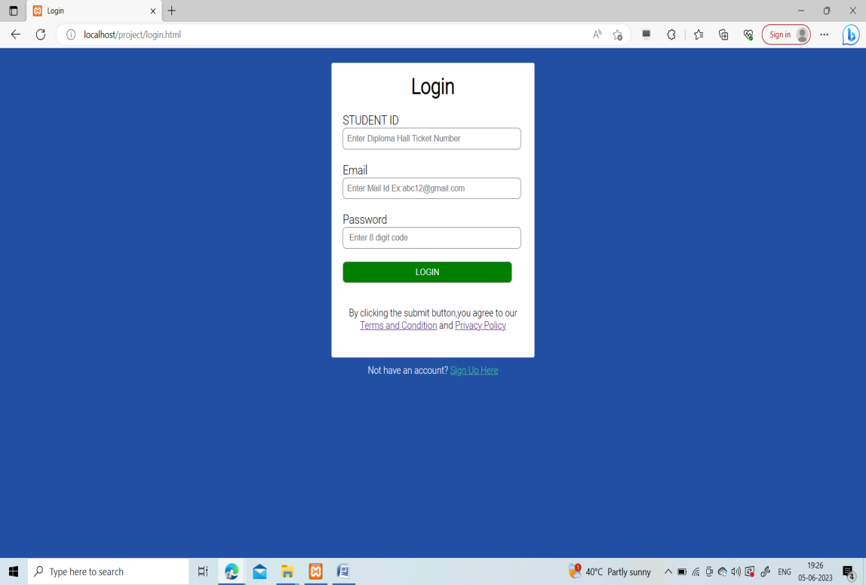

Log in Page

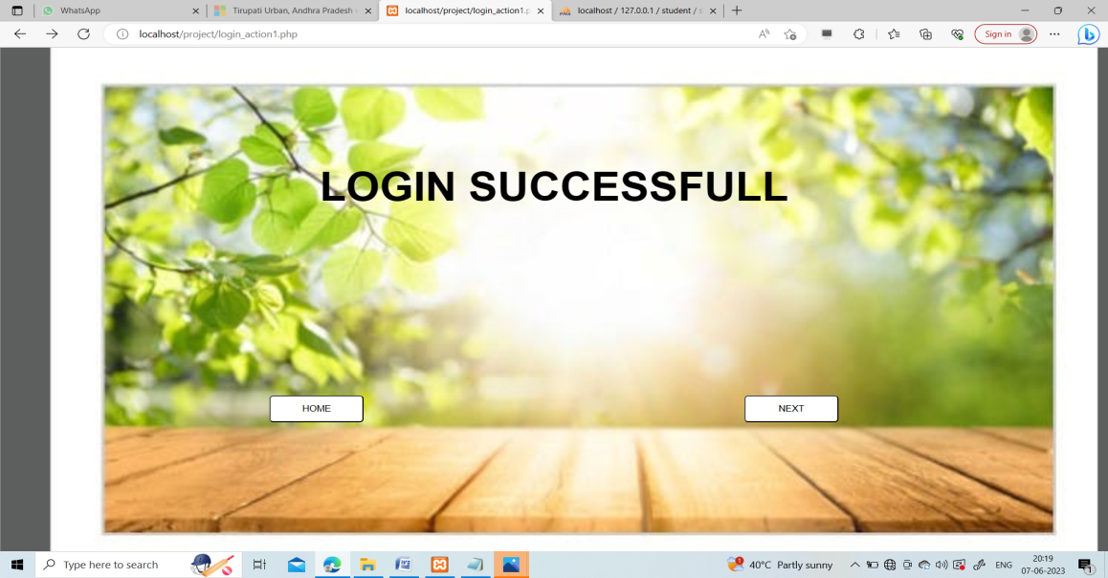

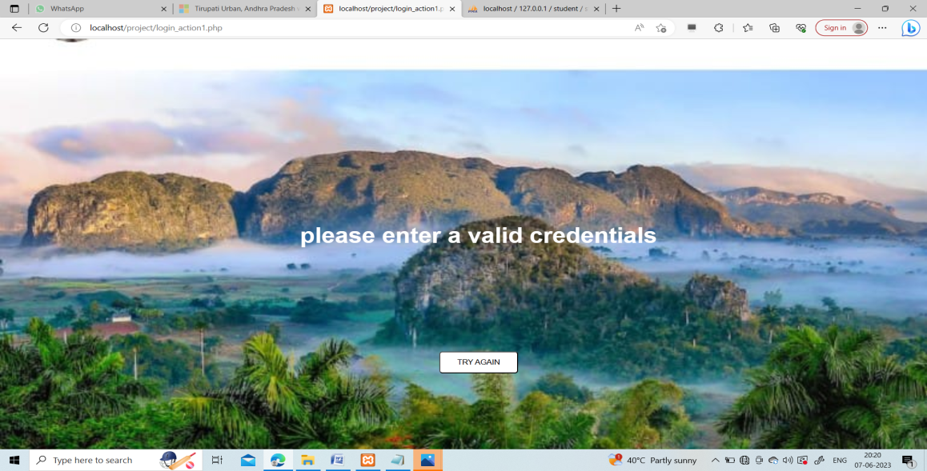

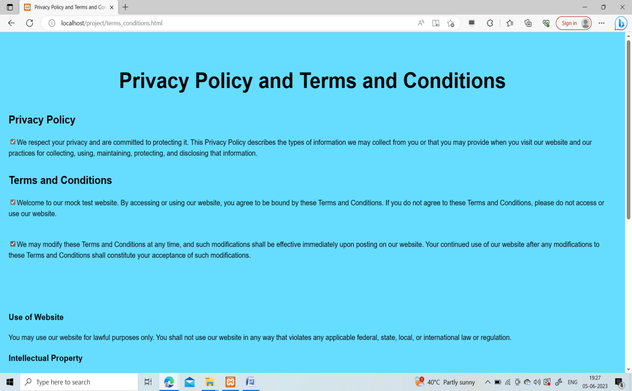

Privacy Policy and Terms And Conditions

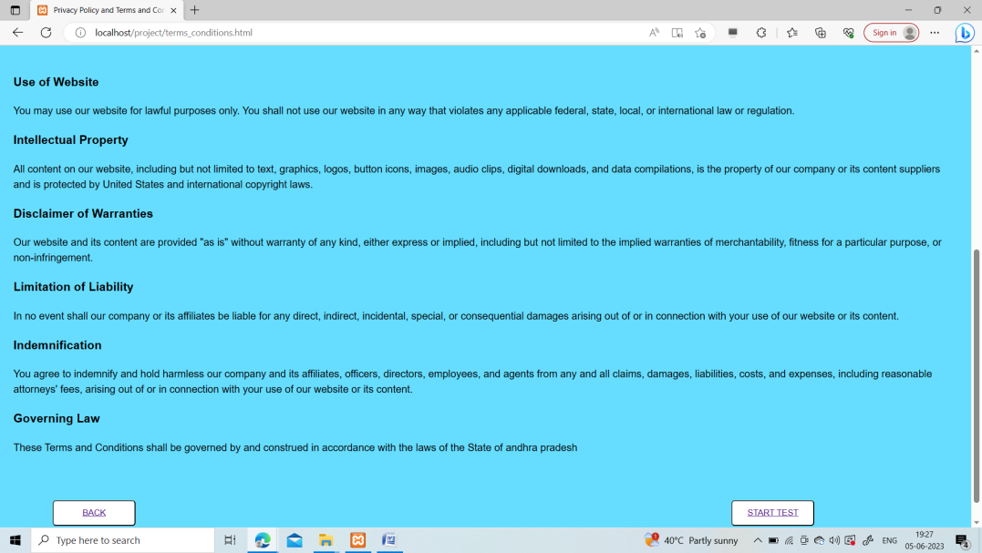

Privacy policy and Terms and Conditions 1.1

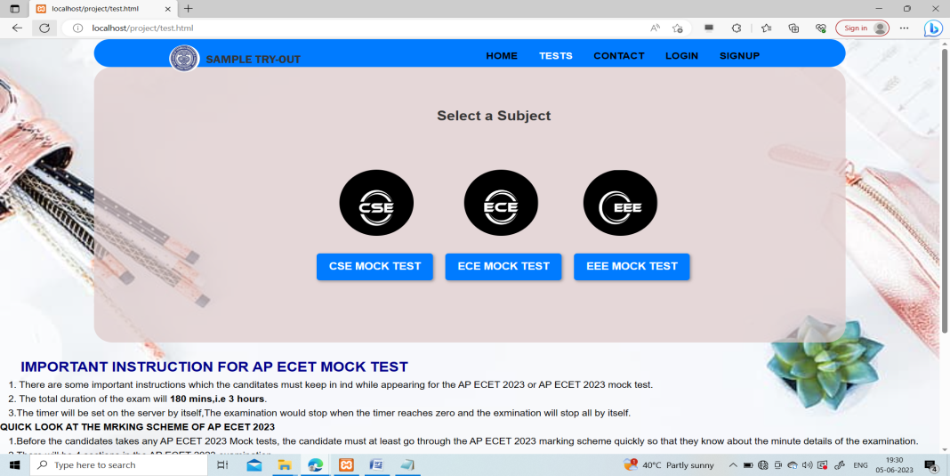

Test Access page 1

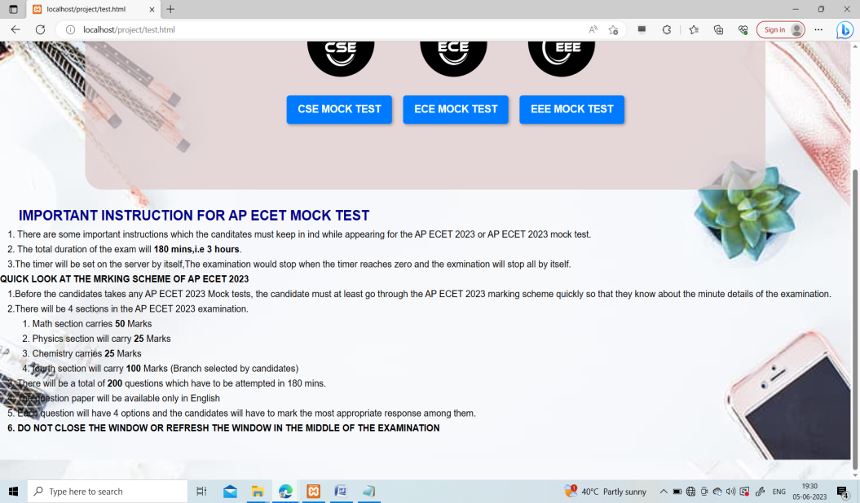

Test Access Page 1.1

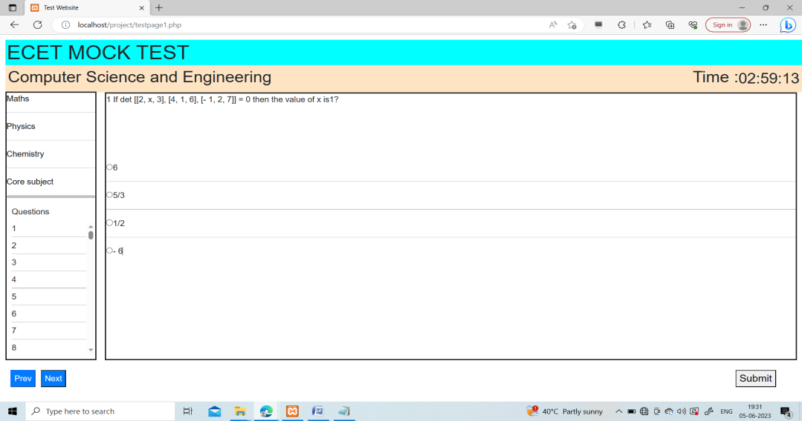

Test Page of Department of Computer Science and Engineering

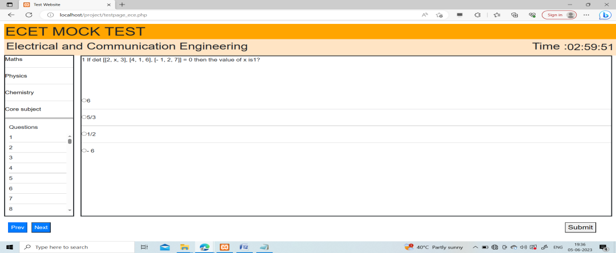

Test Page of Electrical and Communication Engineering

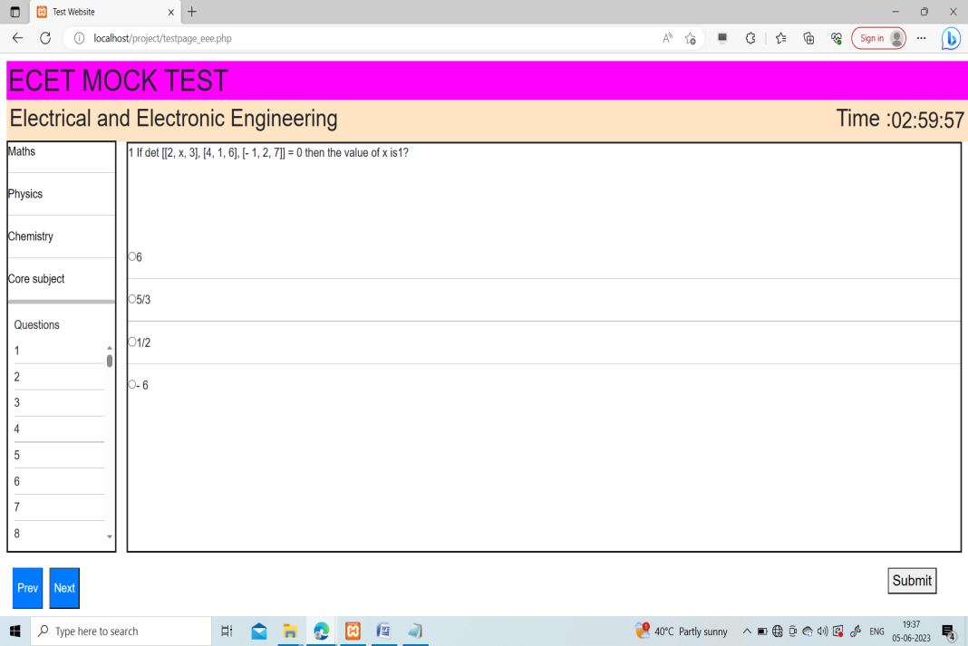

Test Page of Department of Electrical and Electronic Engineering

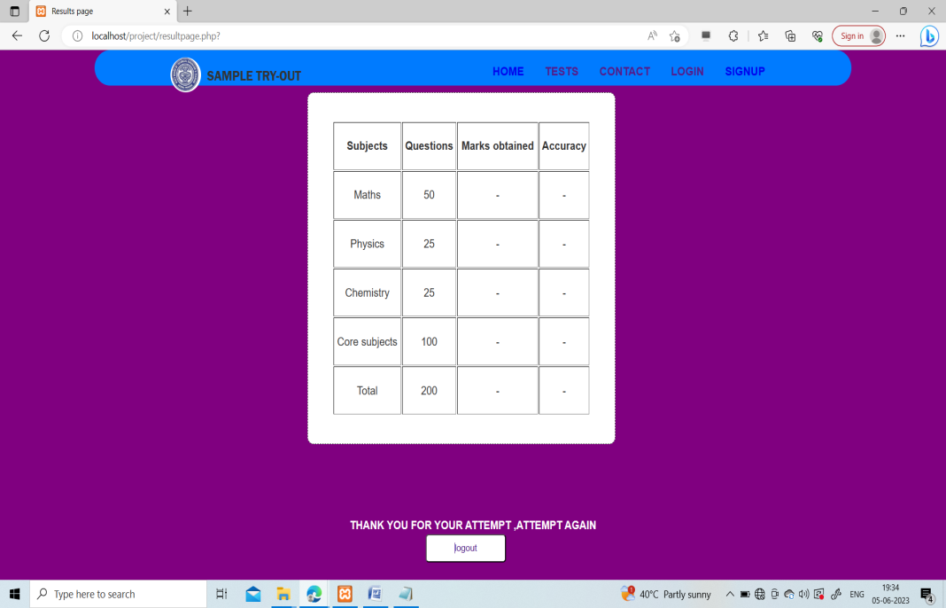

Result Page of all Test Pages

